>Show Databases; – displays all databases present.

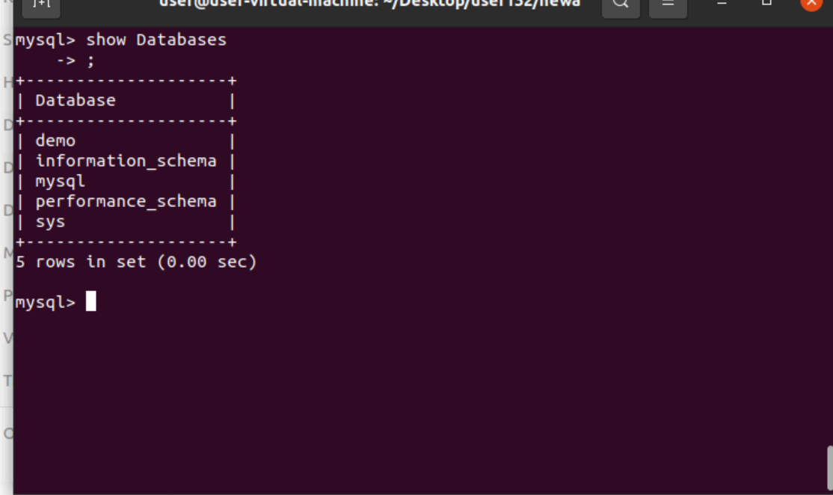

>show tables;

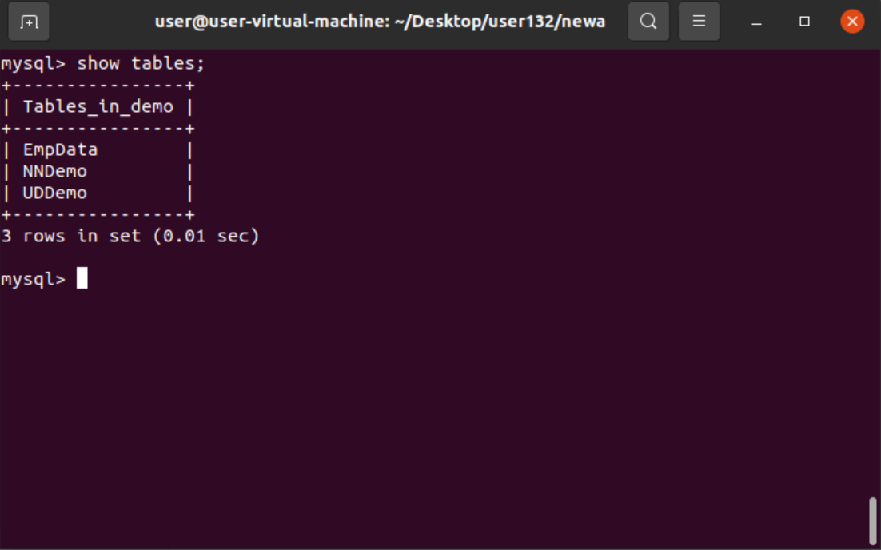

>Desc demo.EmpData; – displays description of table.

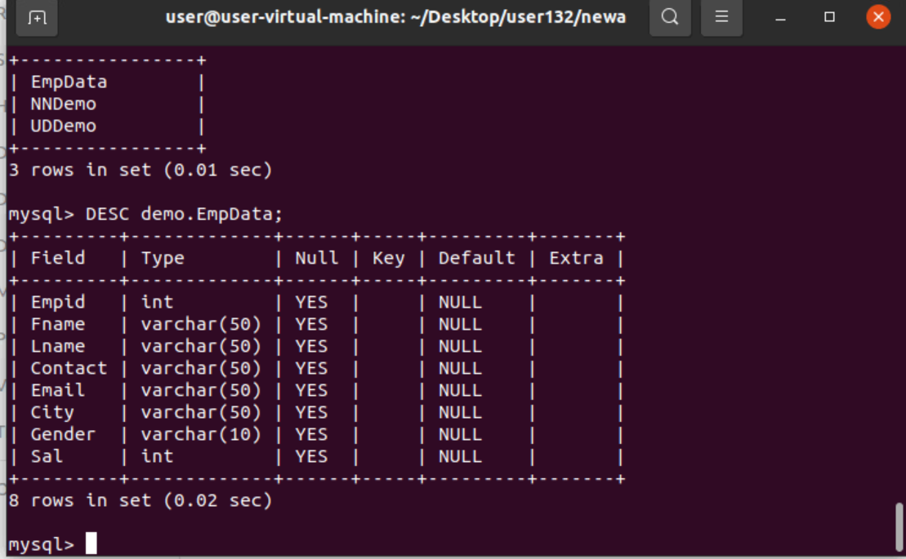

>select distinct from table; – it removes duplicates.

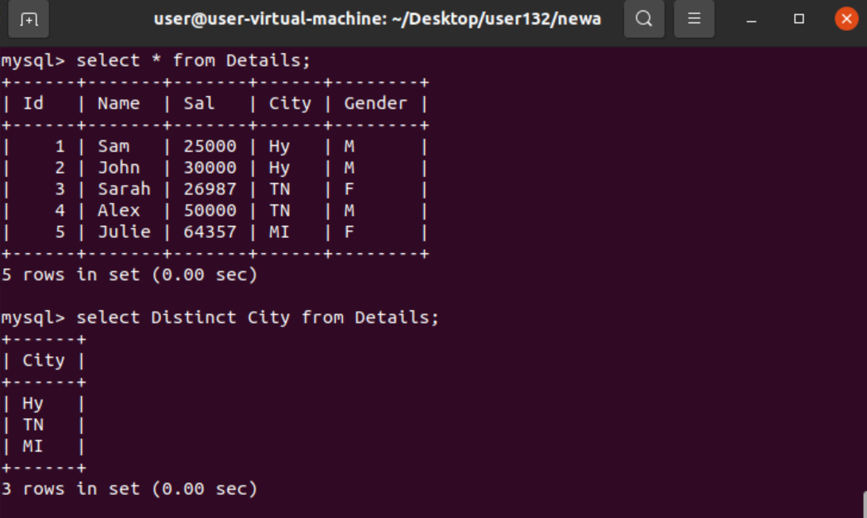

>select \* from tablename where city=’’;

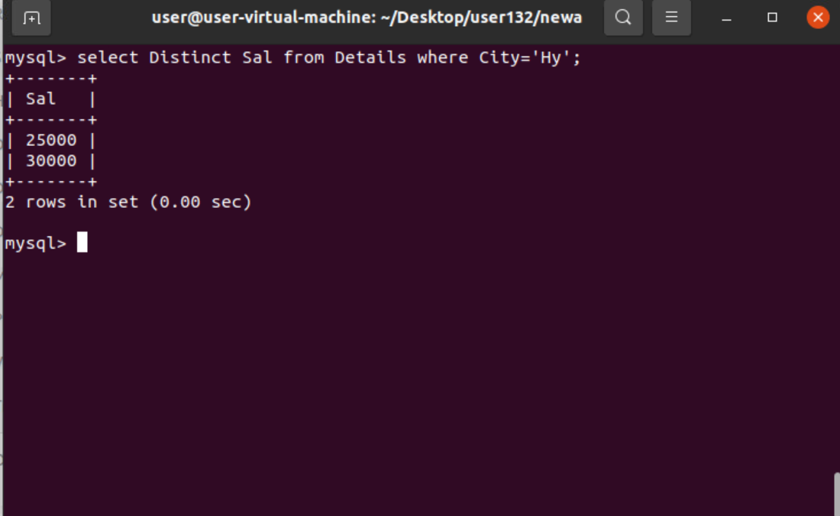

>select distinct(count city) from tablename;

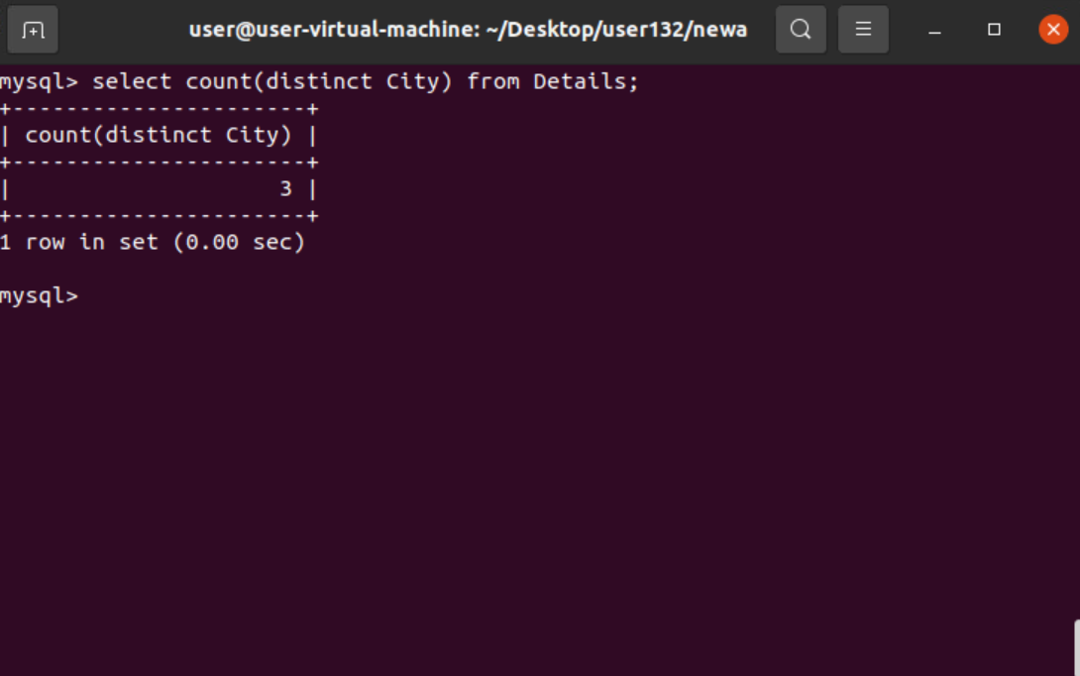

>select \* from tablename where Gender=’M’ and Sal>25000;

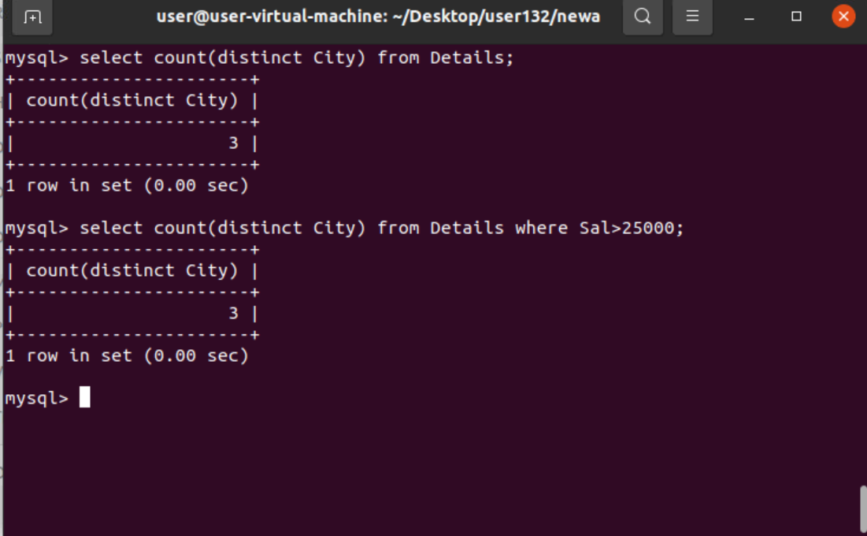

>Select \* from tablename where gender=’m’ and sal>25000;

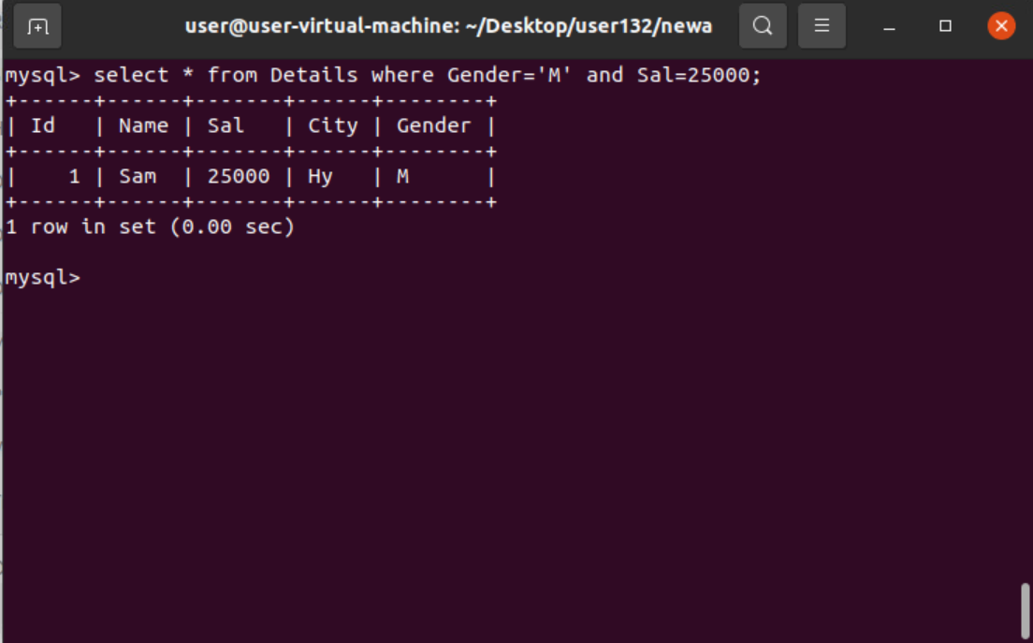

>select \* from tablename where gender=’F’ or sal>25000;

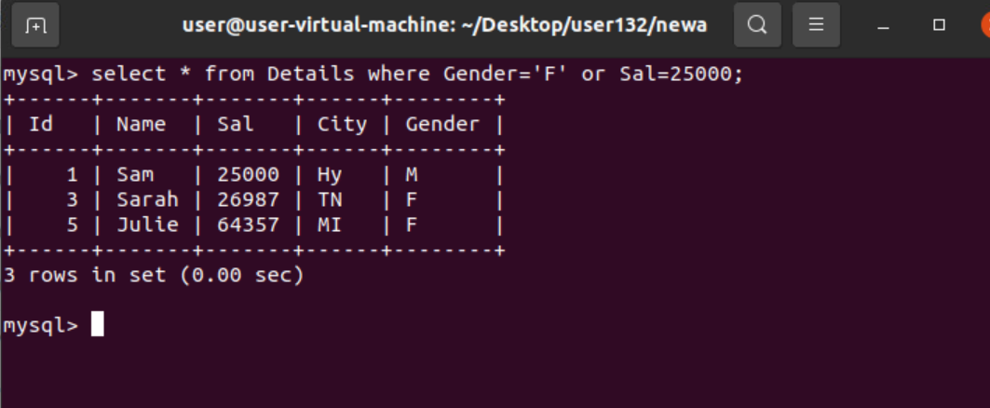

>select \* from tablename where not city=’hy’; – NOT displays except all given data.

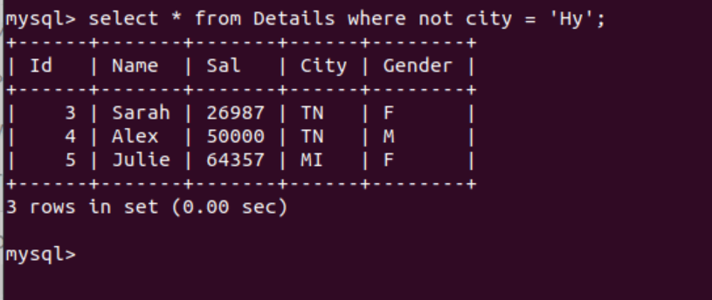

> select \* from tablename where not city=’hy’ and not sal=30000;

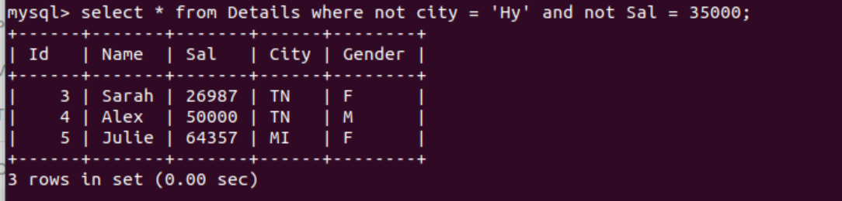

> select \* from tablename where not city=’hy’ or not sal=30000;

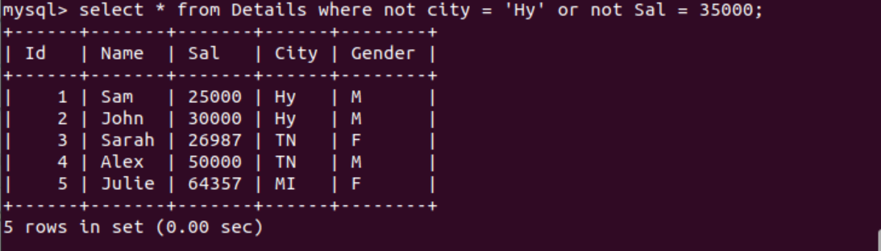

>select \* from Details where Sal>=15000 and Not city=’tn’ order by name Desc;

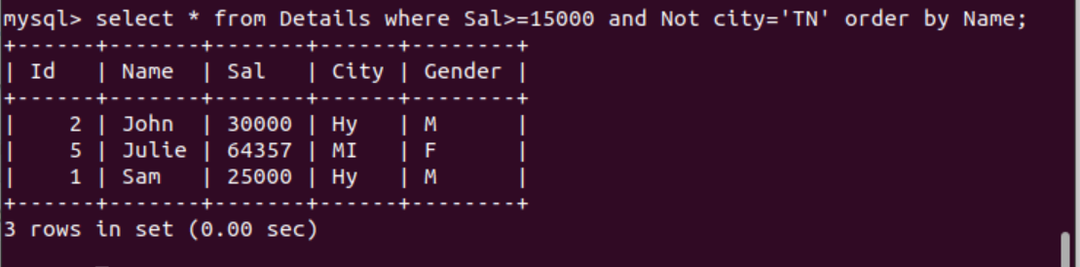

>Update details set city =’pune’ , Sal=55000 where Id=5;

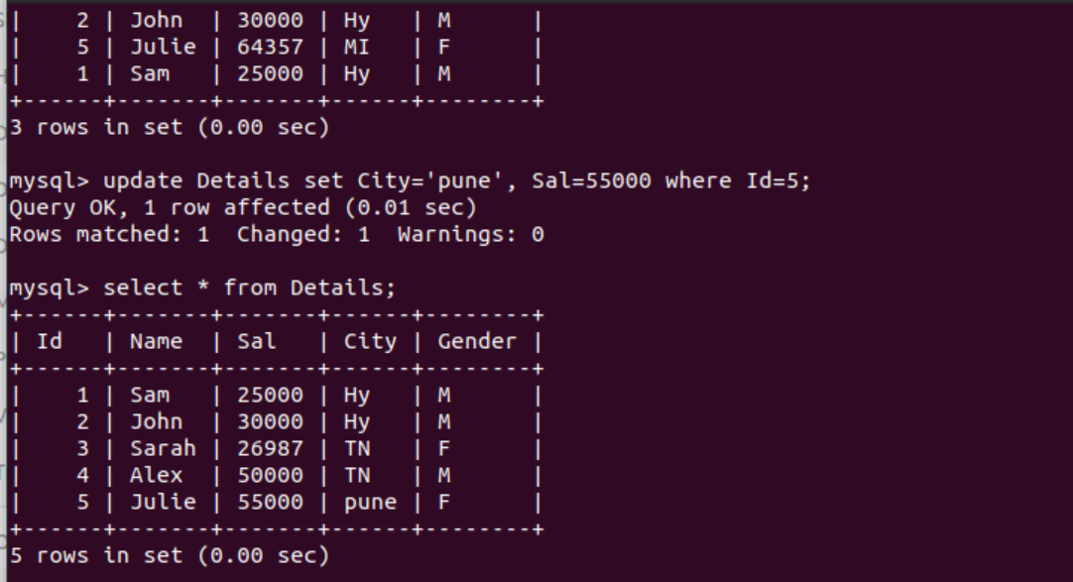

>select \* from tablename limit 1..2…; - Limit used to show limited output.

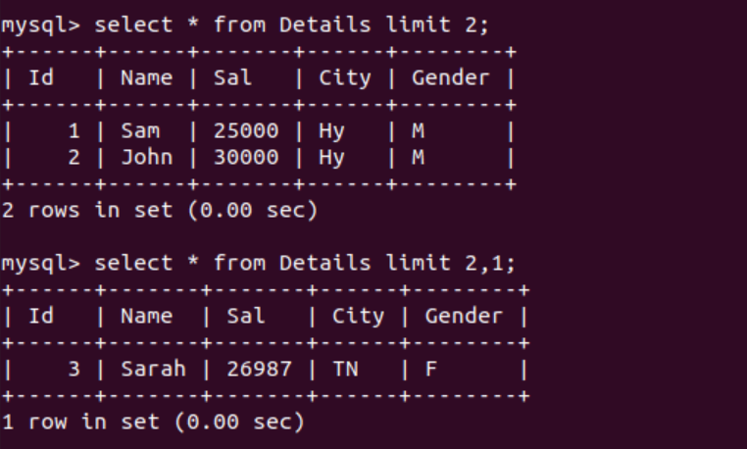

>select \* from Details order by Sal Desc limit 3;

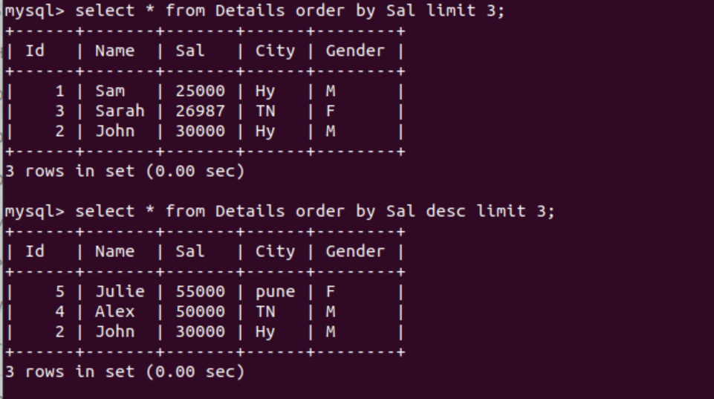

>select \* from Details where city is null;

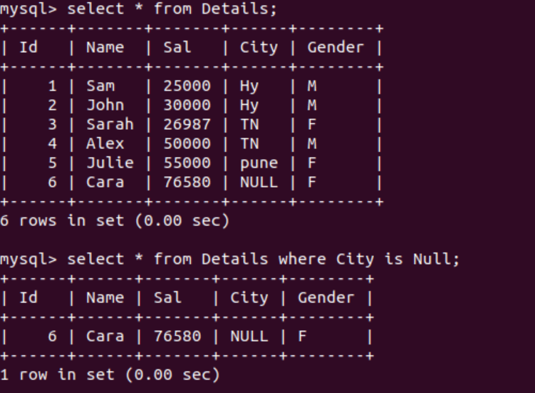

>update details set city=’mi’ where id=6;

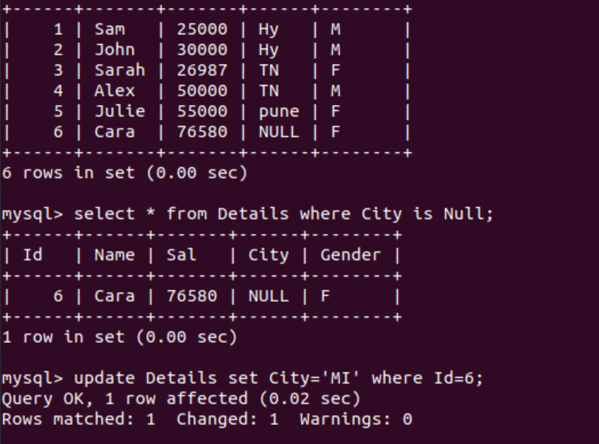

>delete from tablename where Name=’max’;

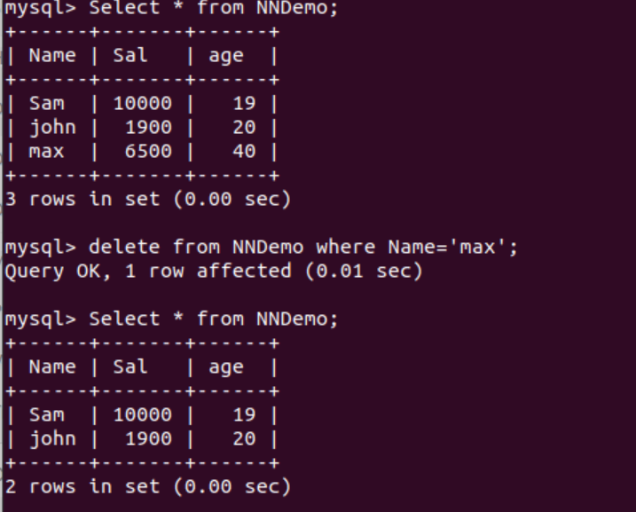

>alter tablename drop columnname;

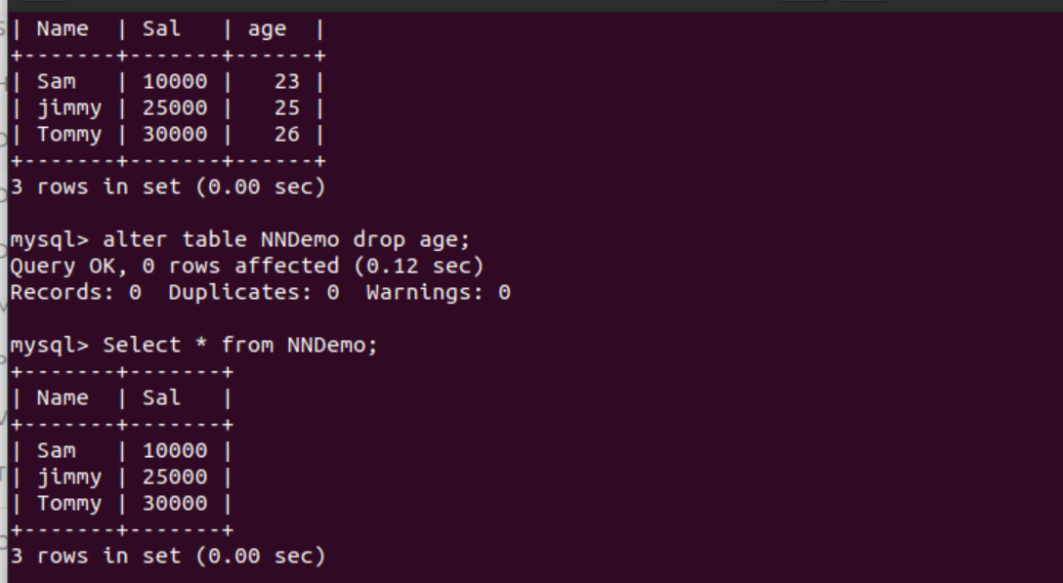

>drop table tablename;

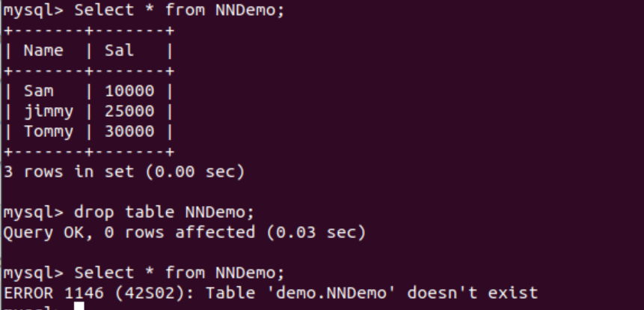

>LIKE query

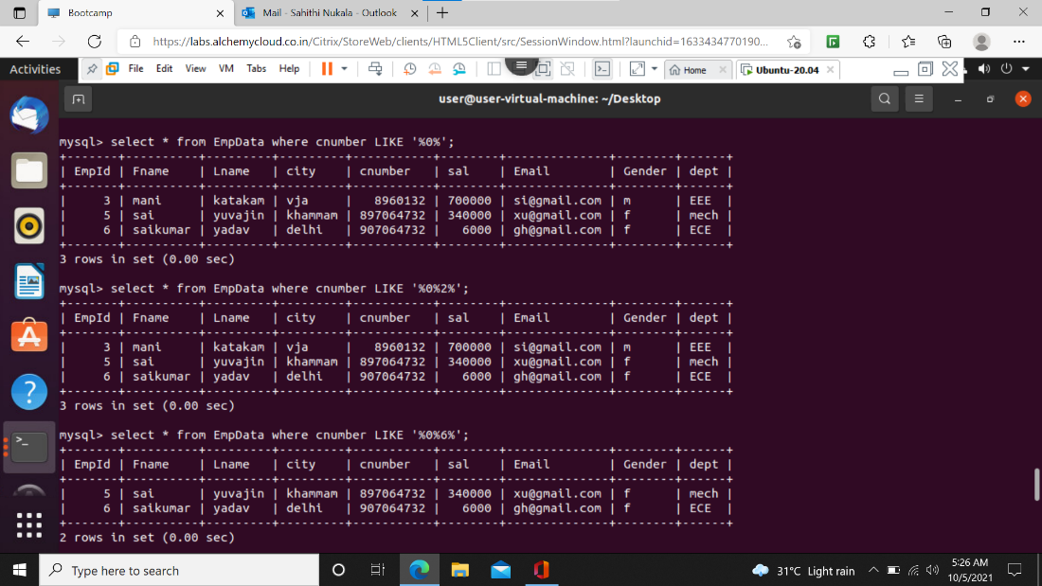

>in & not in

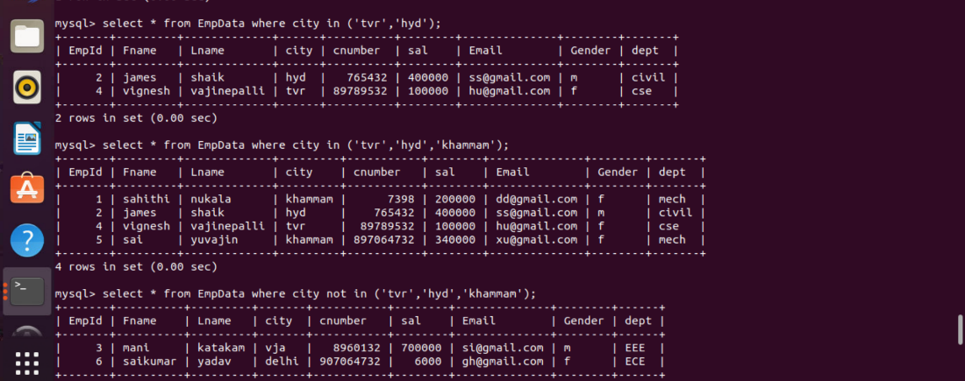

>Between

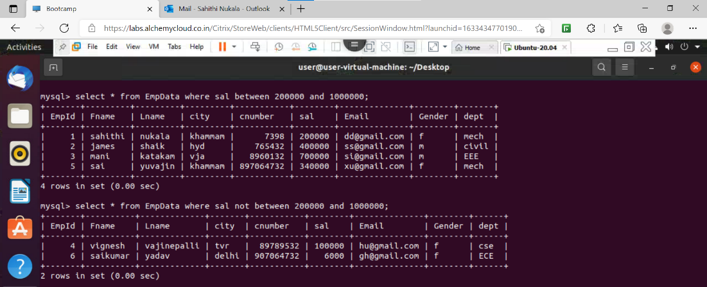

>Group by Clause

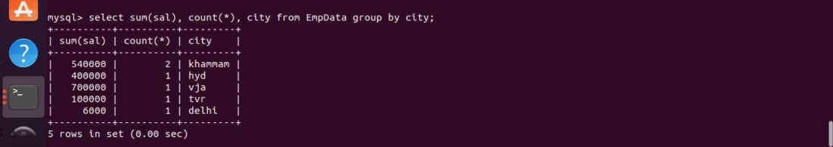

>Having clause

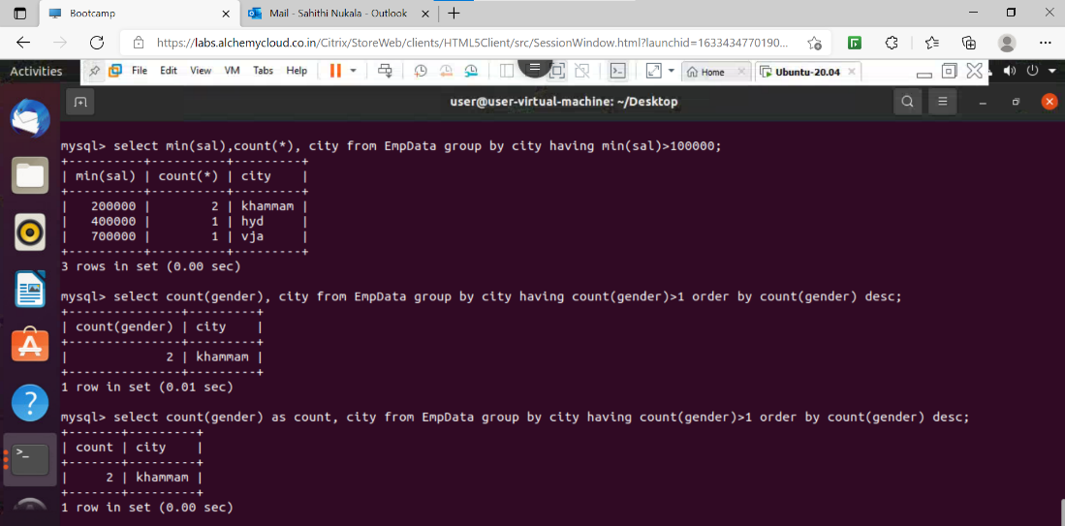

>not null constraint

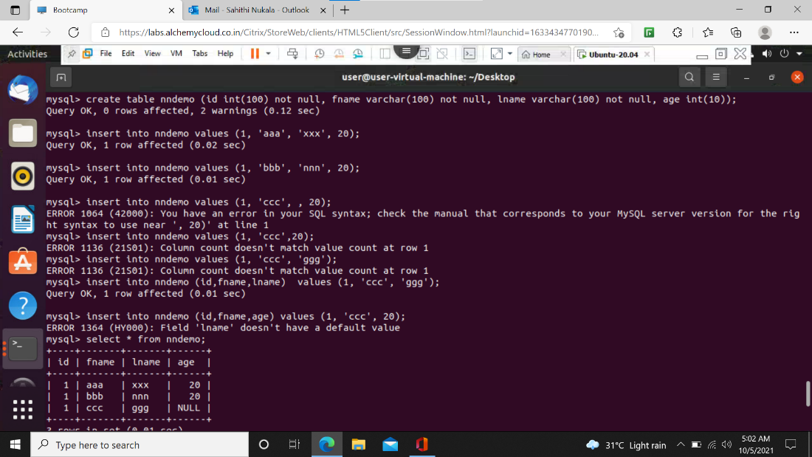

>Show tables query for showing tables in the selected database.

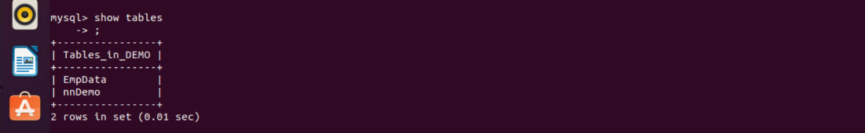

>Rename query

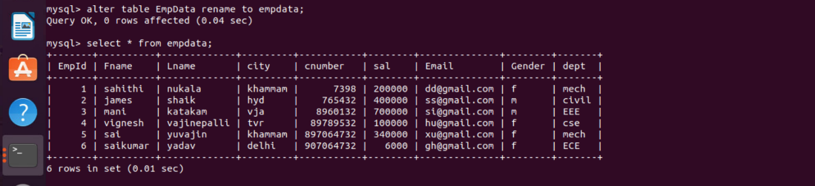

>Default constraint

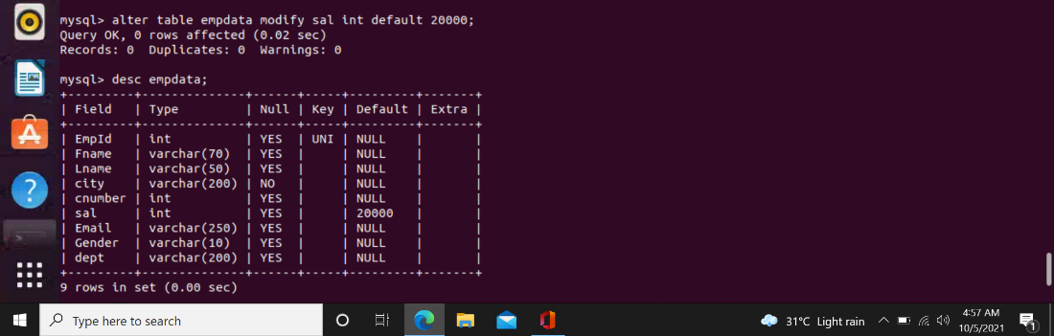

>Check constraint

